SIR SYED UNIVERSITY OF ENGINEERING & TECHNOLOGY
COMPUTER SCIENCE & INFORMATION TECHNOLOGY DEPARTMENT

Spring 2025
Cloud Computing (CS-492T)
Assignment # 2

Semester: 6th Batch: 2022F
Announced Date:03-06-25 Due Date:20-06-25
Total Marks: 3 Marks Obtained:
Instructor Name: Engr. Tehmeed Ebaduddin

Name:Muhammad Faisal
Roll#: 2022F-BCS-152
Section: A
CLO # | Course Learning Outcomes (CLOs) | PLO Mapping | Bloom’s Taxonomy
CLO 2 | Explain system, network and storage virtualization, outline their role in enabling the cloud computing system model. | PLO_2  (Knowledge for Computing Problem) | C2  (Understanding)

Q1. Demonstrate the steps to create a public load balancer to load balance VMs running Apache2 and
NGINX web server using the Azure portal. Attach all the necessary snapshots of the Load balancer
and the web server with IP address.

- Create Virtual Network (VNet)
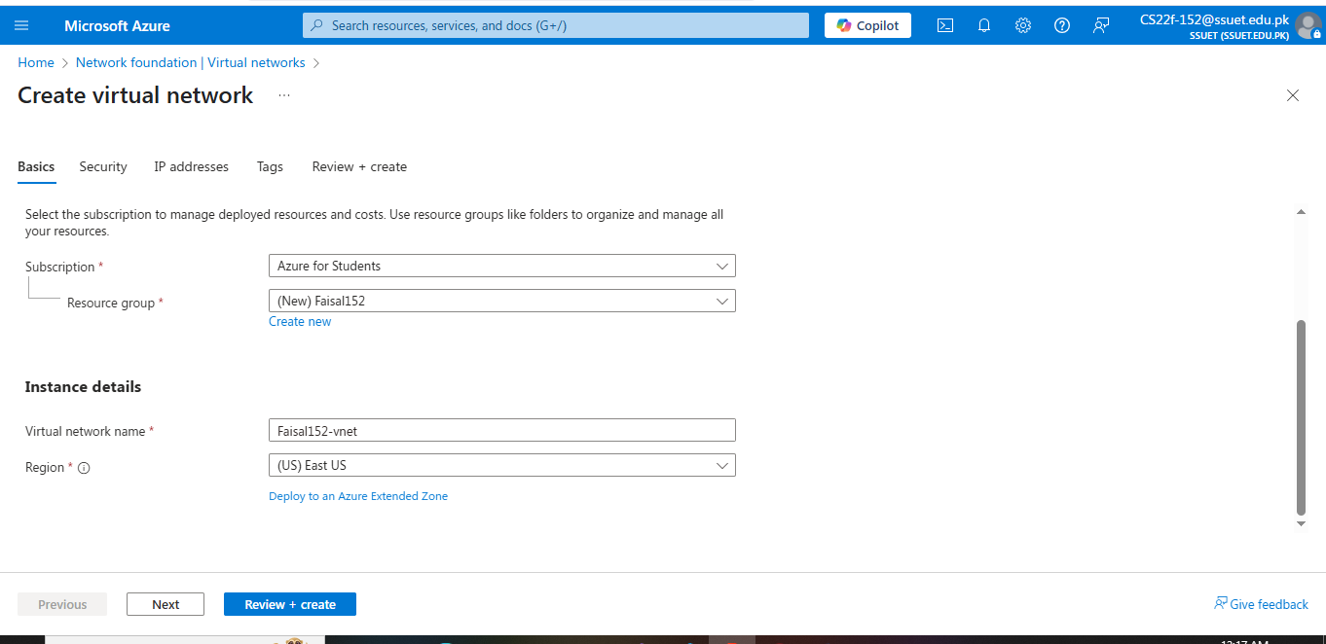

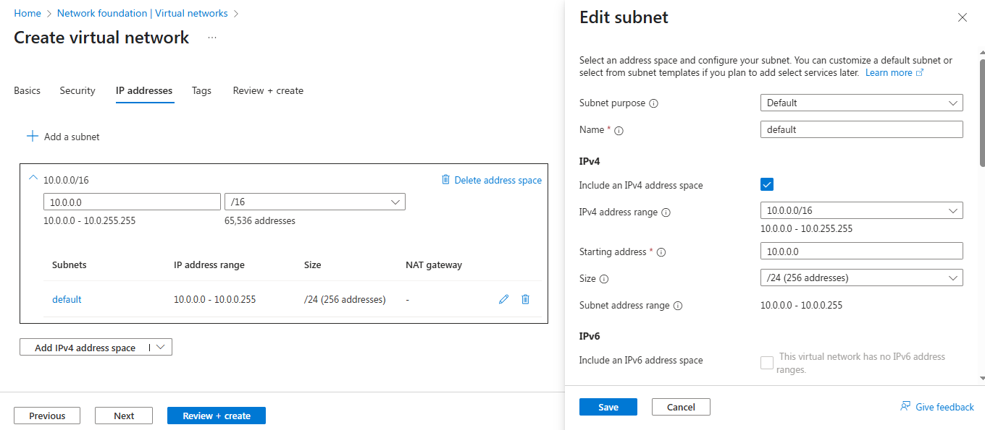

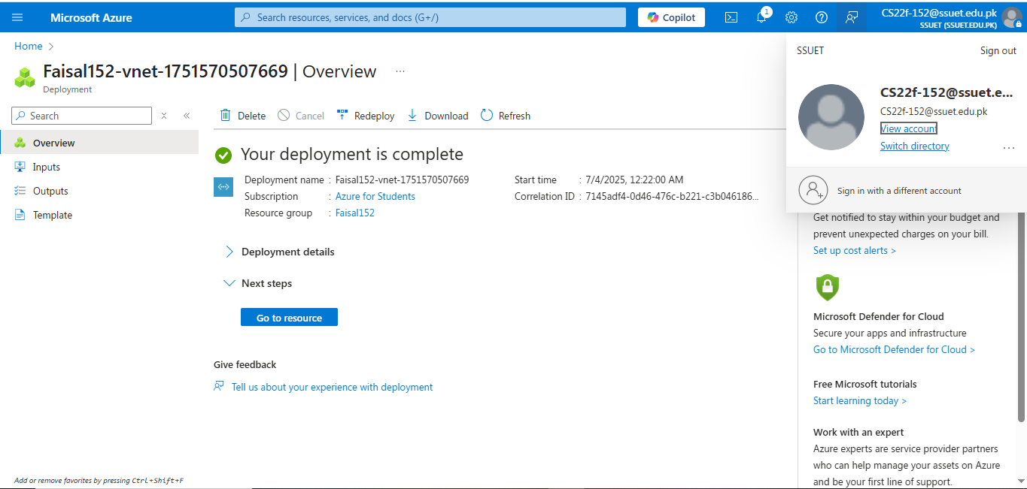

- Create VM1 (Apache2)
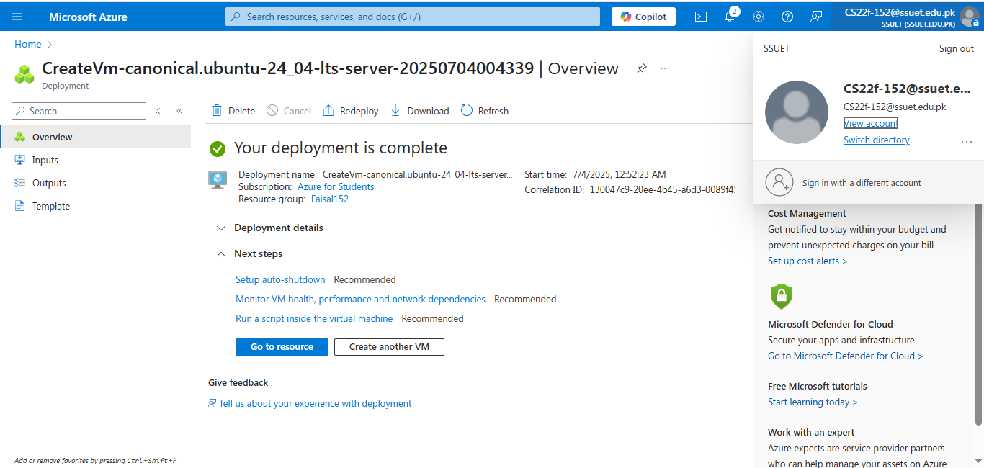

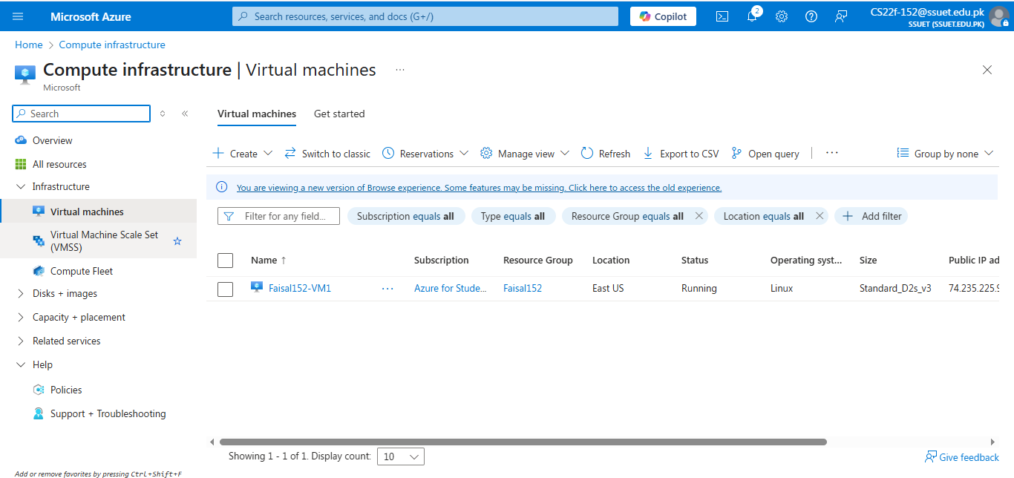

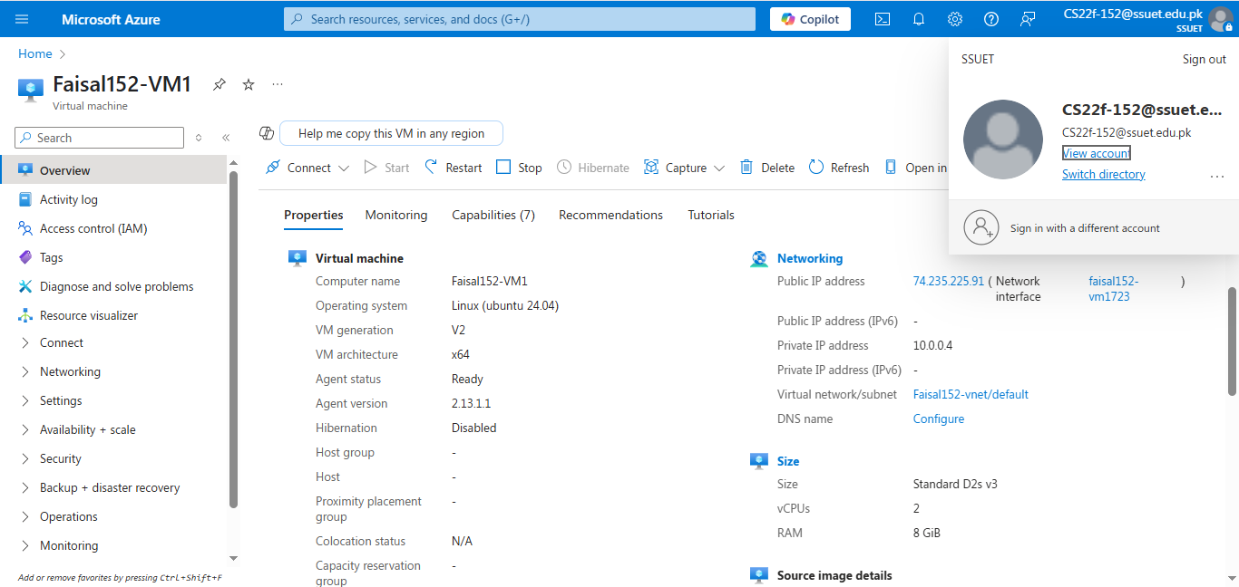

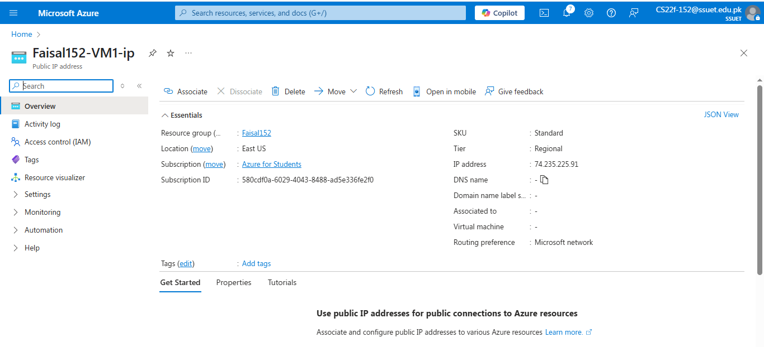

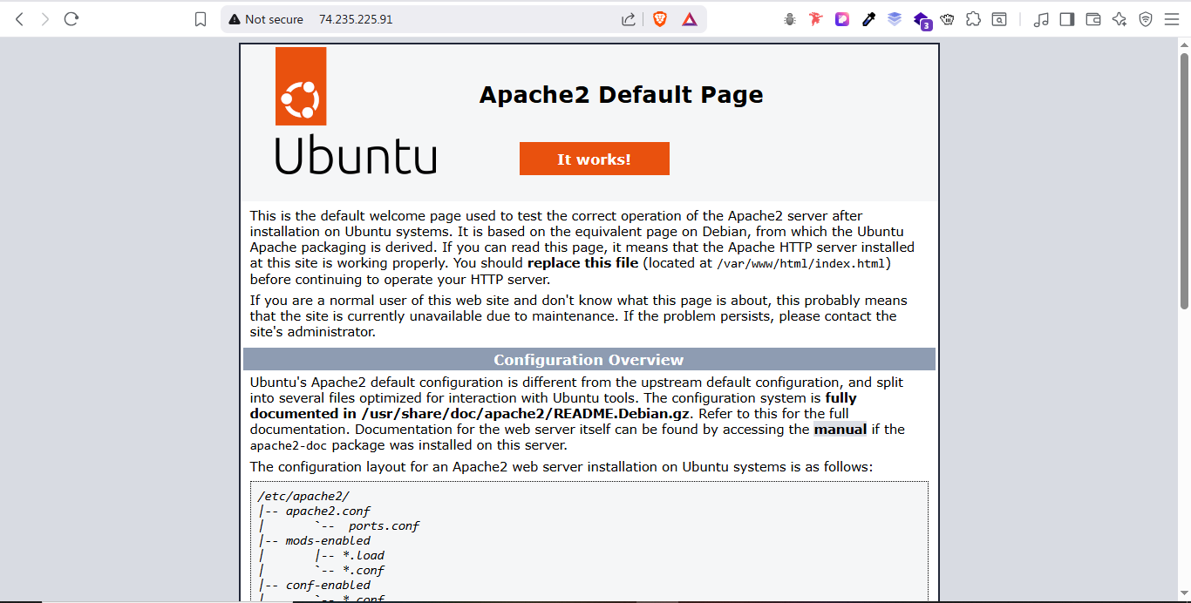

- Create VM2 (NGINX)
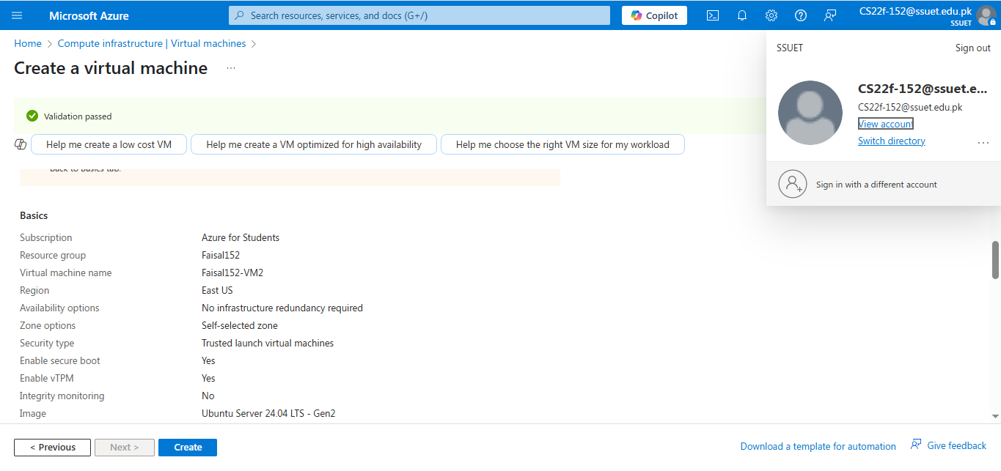

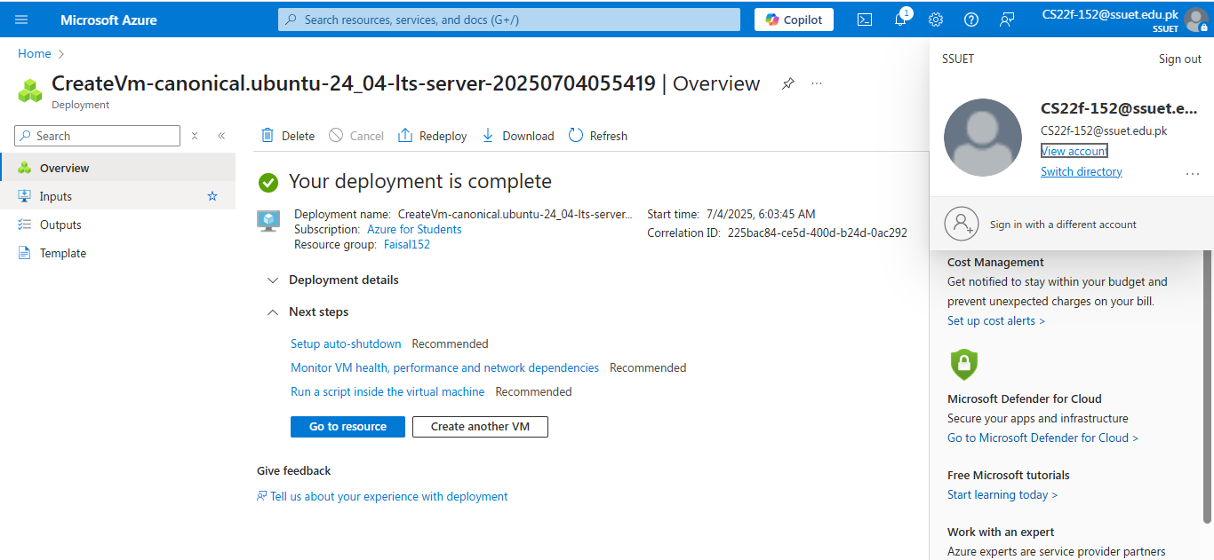

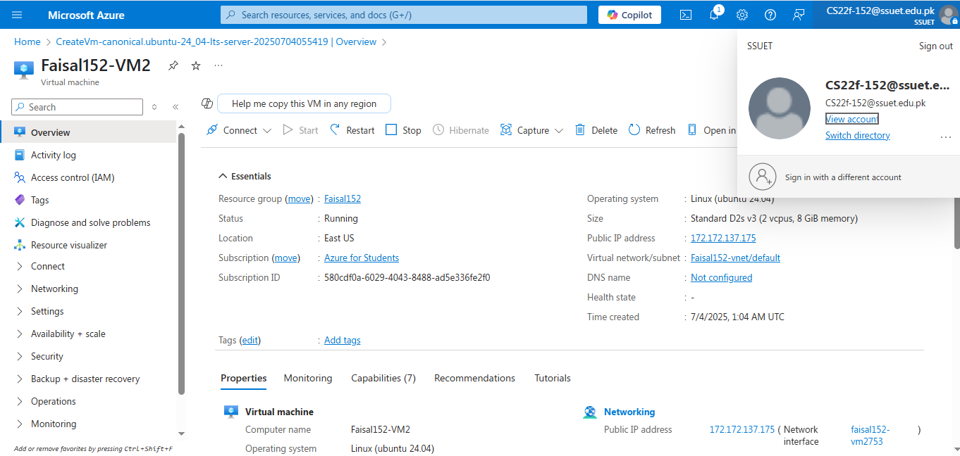

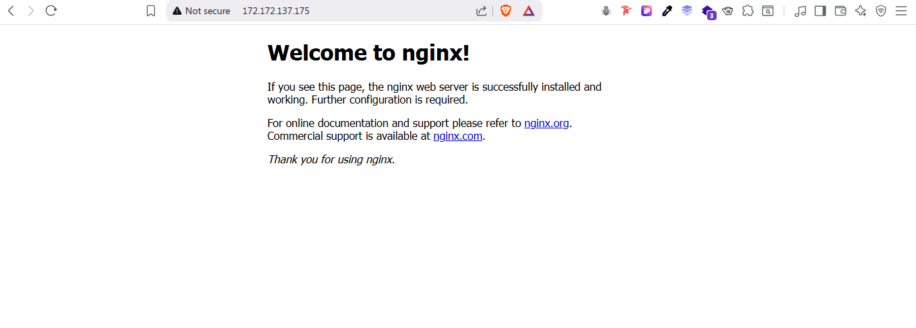

- Create Azure Load Balancer
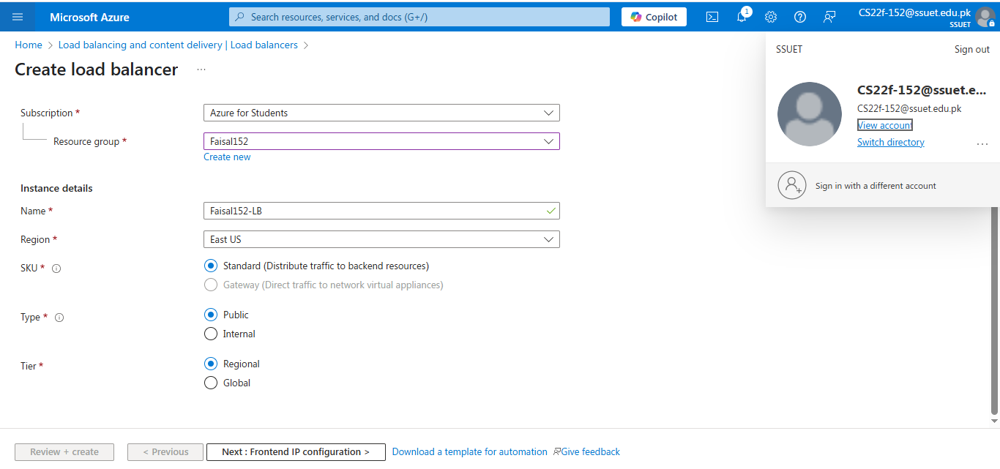

- Add frontend IP configuration
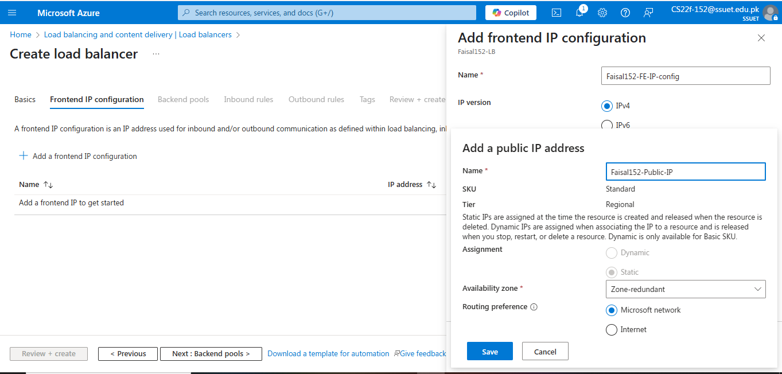

- Add Backend Pool
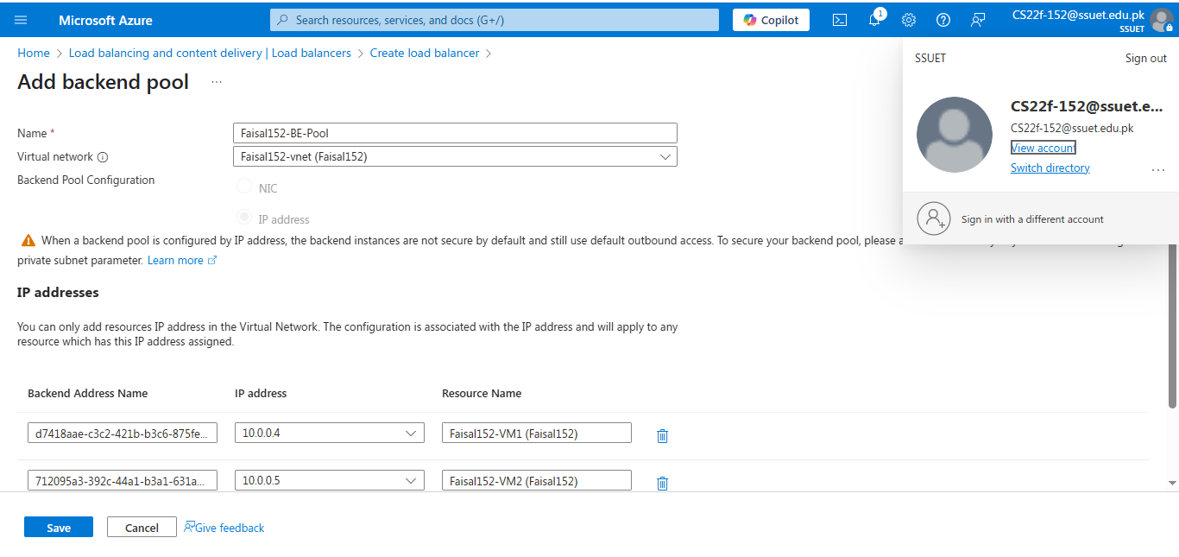

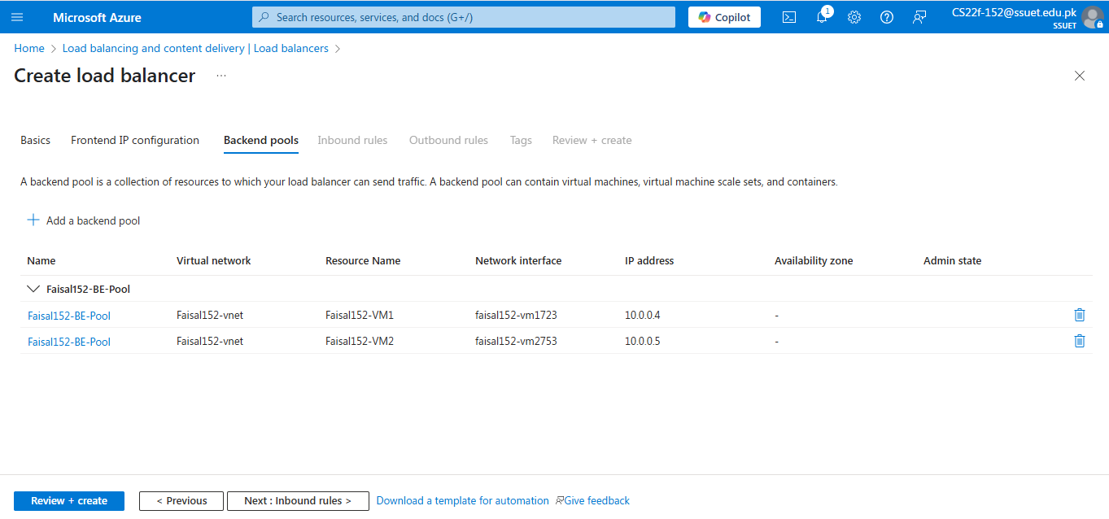

- Add Load Balancing Rule
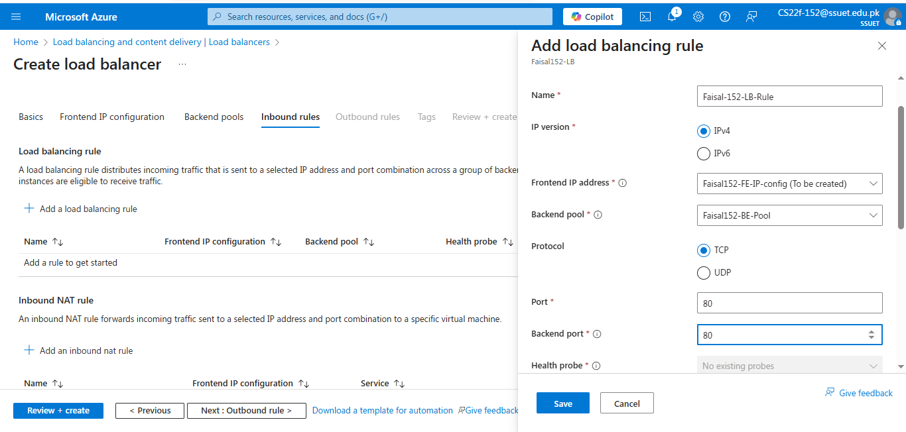

- Create Health-Probe
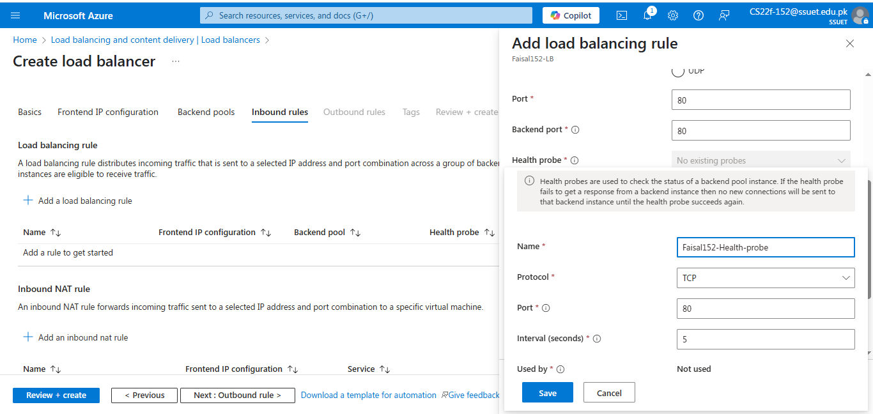

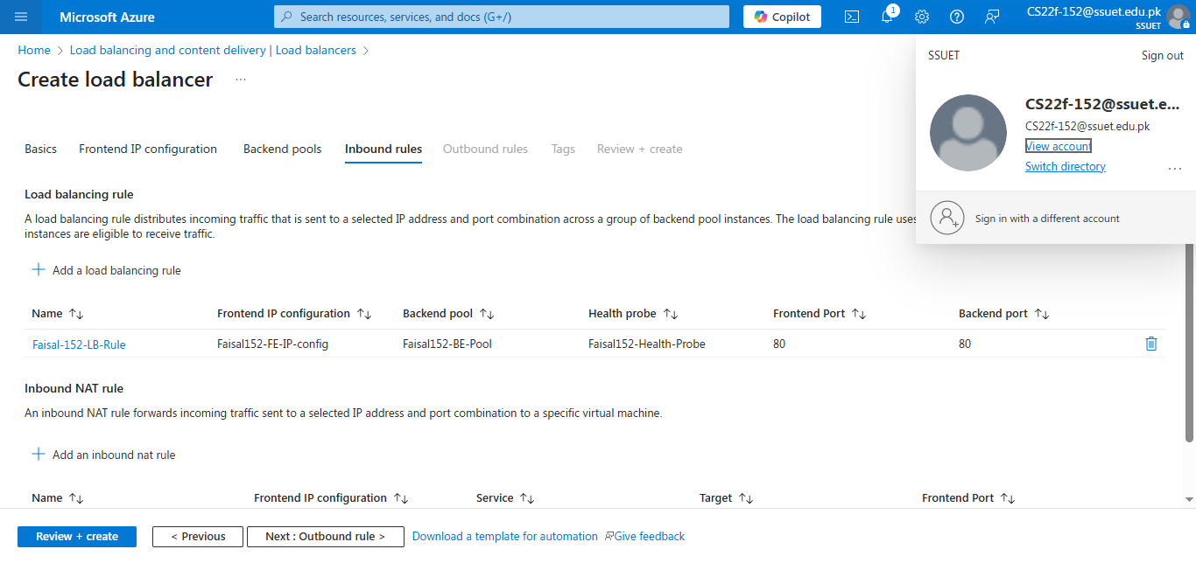

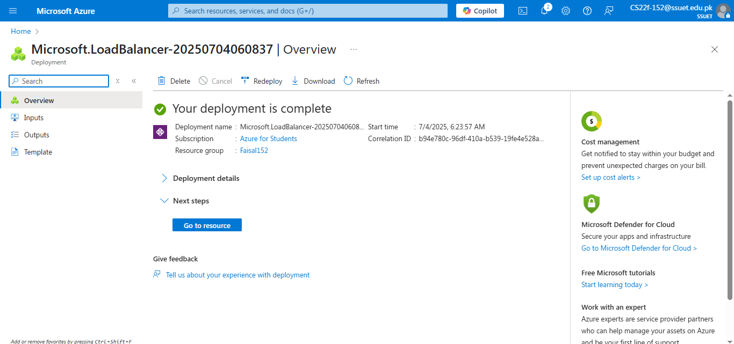

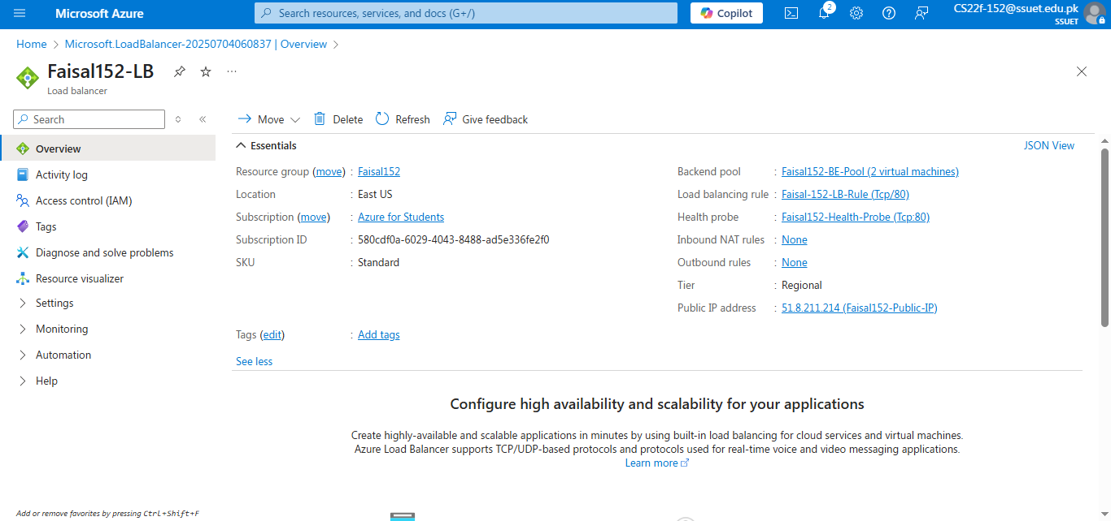

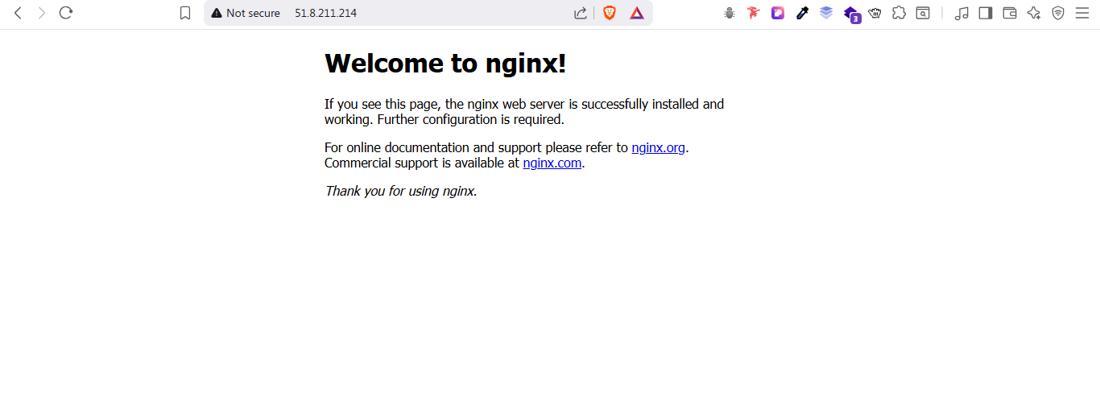

- Since the VM2 (NGINX) is turned off the Load Balancer is serving the web server Apache2
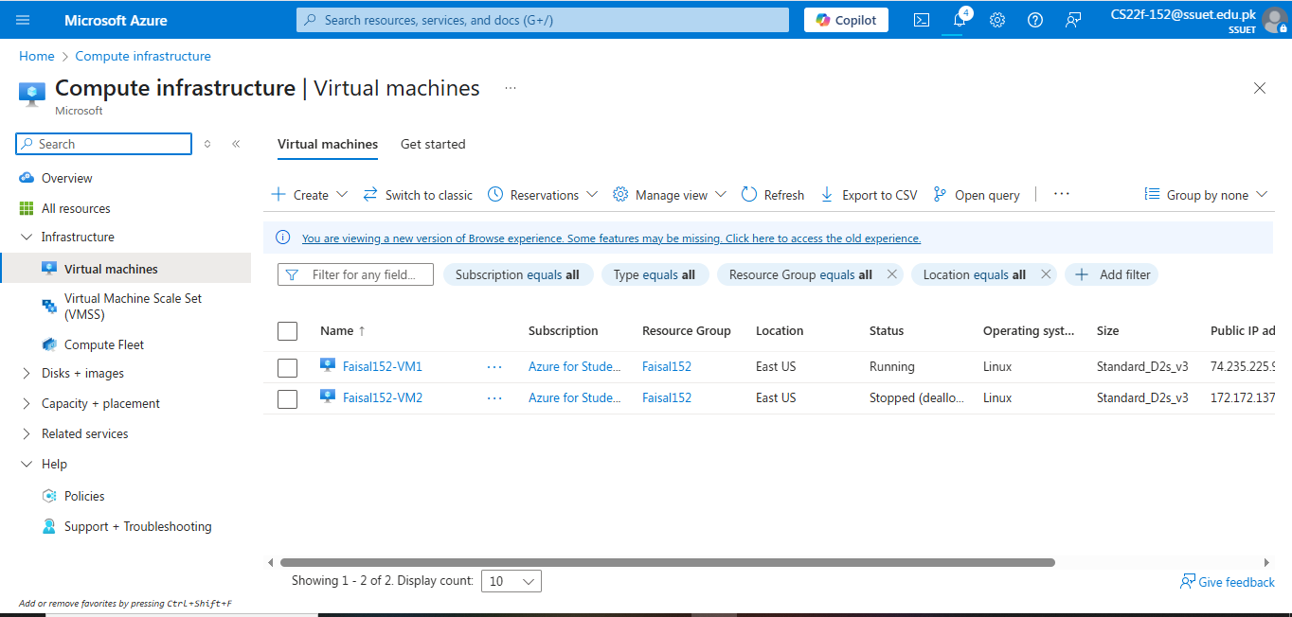



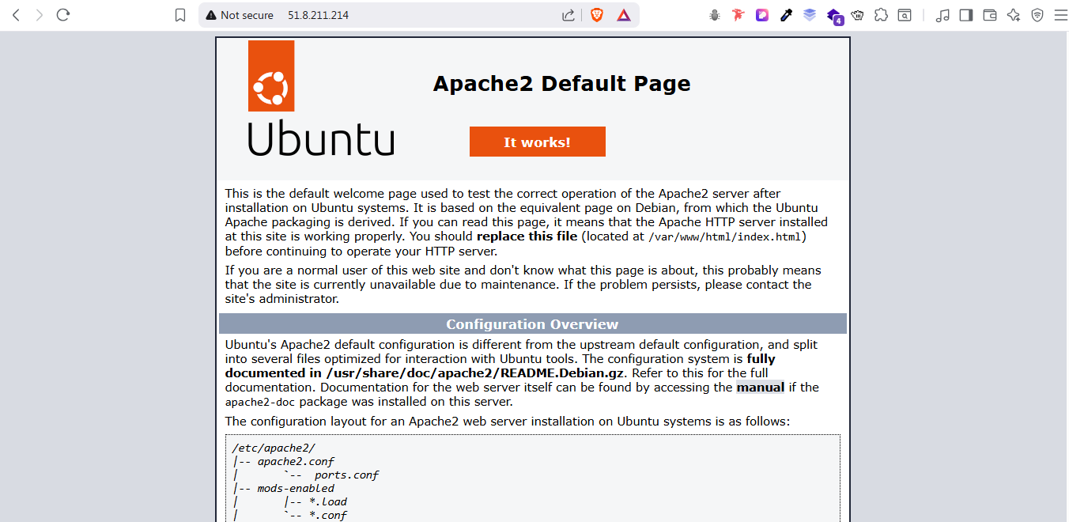

- Dissociate VM public IP on Azure
